|  |  |  |  |  |
| --- | --- | --- | --- | --- |
| Title: Part 1 Storyboard    Piha | | | | |
| Description |  | Elements |  | |
| Duration |  | Elements animation |  | |
|  | | | | |
| Piha | | | | |
| Description |  | Elements |  | |
| Duration |  | Elements animation |  | |
|  | | | | |
| Wild | | | | |
| Description |  | Elements | |  |
| Duration |  | Elements animation | |  |
|  | | | | |
| Scenic  Text-2  Name/ID | | | | |
| Description |  | Elements |  | |
| Duration |  | Elements animation |  | |

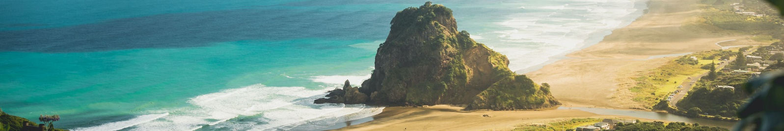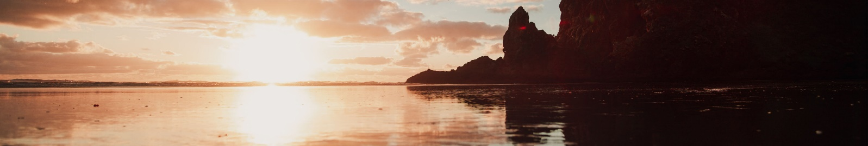

Text-2